**Two way synonyms**

So, requirements are

***term****: computer* ***synonym list****: laptop,notebook*

Output of this will be three groups.



Second set from user

***term****: notebook* ***synonym list****: portable-pc,netbook*

**

**In my opinion second picture has a mismuch and should look like this acording to the requirement of the first set and the sentense from the requirement**

***“ This means that each of synonym word in synonym list becomes a term for previously word used as a term.”***

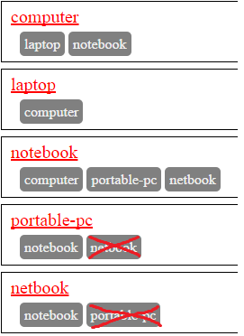

So, please point me to the correct understanding.

I used an understanding from the previous picture and my output looks this way:

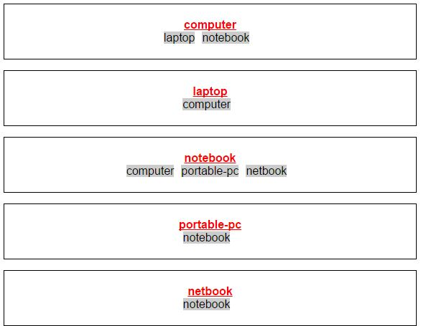

**How to run the application:**

1. Unpack the Synonyms folder.
2. Open Synonyms.sln and run the application
3. In case if you get an exception regarding the SQL Compact edition. Make sure that you have installed this tool.

<https://www.microsoft.com/pl-pl/download/details.aspx?id=17876>

**Some words about implementation:**

1. When the application starts first time it will create a database within the folder **App_Data** and insert one row to the database. During the second execution it will be user an existing database.
2. Communication with the database has beed done via EF code first to SqlCE.
3. During the first load of the page, javascript method call the server and receive the data from WebAPI method via AJAX.
4. When user is going to post a synonym, he should fill the fields **Term** and **SynonymList.** After posting the data comes to the database and on the page side will be executed the method from item 3.